**PDU Data Parse Tool v0.8**

Documentation and Instructions

PLEASE NOTE

The PDU Data Parse Tool is available as both an AHK file and as an EXE file.

The EXE format should be able to run on any computer.

The AHK file contains the readable/editable script code, and can only be run on computers which have had [AutoHotkey](https://autohotkey.com/) (click here for [Direct Download](https://autohotkey.com/download/ahk-install.exe)) installed.

Additionally, the Tool is written to expect the use of PuTTY to communicate with the PDUs. Use of PuTTY is strongly recommended. If PuTTY is not available, please contact [james.ferris@arris.com](mailto:james.ferris@arris.com) for assistance.

To maintain the correct filename of the parsed data, PuTTY log files should be configured to have a three (3) character extension, such as .log or .txt.

INTRODUCTION

The PDU Data Parse Tool is intended to help speed up and automate most of the tasks associated with gathering data from Server Tech PDUs via the Command-Line Interface.

The Tool has two functions: The first function automatically sends the required commands to the PDU using PuTTY, and utilizes PuTTY session logging to write the output of the required commands to a logfile; the second function uses RegEx to parse a selected log file and output the results in a CSV format which can be easily copied over to the standard PHP Audit Rack Inventory.

To begin, run the AHK/EXE to open the tool. You will see the tool GUI:

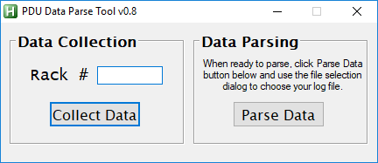

The Tool GUI is separated into two sections. The left section is for sending the commands to PuTTY; the right section is for parsing existing log files.

DATA COLLECTION

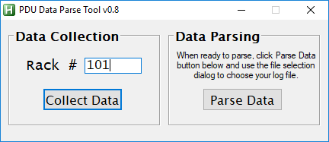

To use the Data Collection function, an open PuTTY session with logging enabled must be available (please see the PDU Data Collection documentation for instructions on how to enable PuTTY session logging). If an open PuTTY session window is not available, you will see the following error:

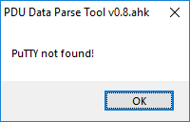

Additionally, the Rack # field must not be blank. Currently, the Rack # field only accepts numbers. If the Rack # field is left blank, you will see the following error:

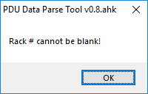

If an open PuTTY session window is available, and the Rack # is entered, clicking **Collect Data** will automatically change focus to the PuTTY session window. The Tool will then send the default login credentials, wait 5 seconds, then send the commands to gather the required data.

Focus will be returned to the Tool window after the commands have been sent.

Please note: If the default login credentials have been changed, you can manually enter them in the PuTTY session and *then* click **Collect Data**, or you can follow the procedure outlined elsewhere to reset the PDU login credentials.

Once the commands have been sent, the console cable can be moved to the next PDU. The same PuTTY session can be used. Enter the new Rack #, and then click **Collect Data** as before. Repeat until all PDUs have been accessed.

DATA PARSING

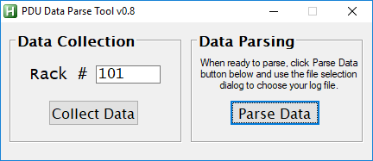

Once Data collection has been completed, the Data Parsing can be done.

Simply click **Parse Data**, then browse to the log file you want to parse.

PLEASE NOTE: The Tool can only be used to parse data obtained using the Data Collection function of the Tool. Log files obtained from manually entering the PDU commands will not parse correctly using the Tool.

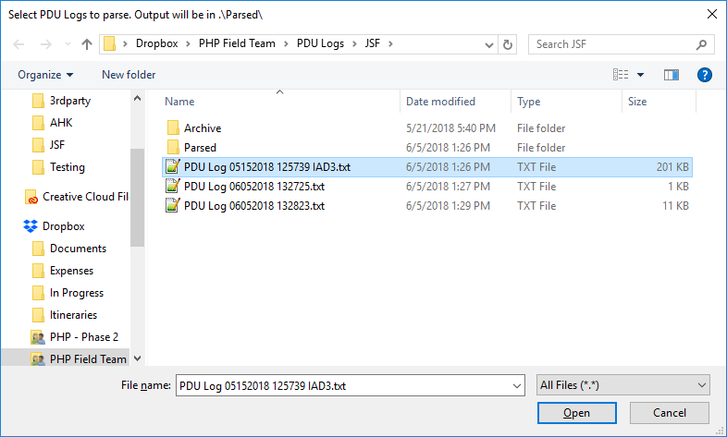

Once the log file is selected, click Open. The file will be immediately processed, and the results will be output using the same filename as the original, with **_parsed.csv** replacing the original three (3) character extension.

